Career and Workplace Essentials – Dr. J. Mior
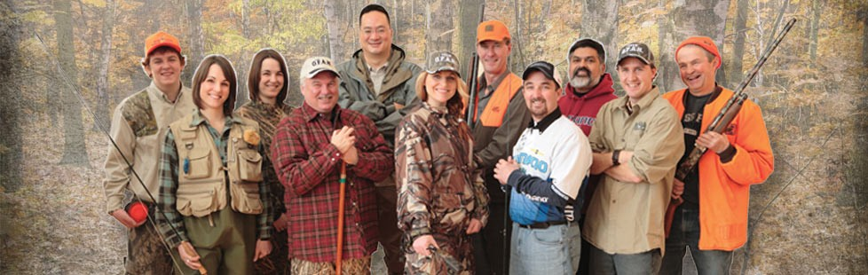Case Study – Ontario Federation of Anglers and Hunters Value 10% Due Date: Friday, Week 6

For this case study you are required to complete the following situational analysis on The Ontario Federation of Anglers and Hunters (OFAH). Your assignment must be word processed using Microsoft Word. Proof read your work carefully before you submit it. Make sure that you are using Canadian spelling. You will submit your assignment digitally to joe.mior@flemingcollege.ca. You will use the following format for your filename for your assignment: CWE_yourlastname_OFAH. Marks will be deducted if you do not name your file properly.

Your main source of information will be obtained from the OFAH web site located at:
Website: http://www.ofah.org

Your final case study report will address the following:

The Organization
• Type of organization
• Mission/vision/mandate of the organization (primary purpose of the business)
• What has OFAH accomplished? Provide some specific examples.
• What are the current outdoor issues?
• What do you think the Federation’s image is in the marketplace? (i.e. how do you think the public and the members perceive this organization?)
• Finances - How does OFAH generate revenue to fund activities and cover operational costs?
• With whom does OFAH partner?

Target Market Customers (Members)
• Who are they? How many? How would you describe the typical member (consumer)?
• How can they use the site?
• How can they use the organization?
• How does OFAH find out what members want from the organization?

Distribution
• How do members access products and services offered by OFAH?

Current Marketing Mix
• What benefits are offered to members?
• What programs does OFAH offer?
• What products and services are offered by the Federation to its members and to the public?
• What projects does the Federation sponsor or work on?
• What promotional techniques are used? (How does the public know about the
Federation?)

Competition
• Does OFAH have competition? Who? What type?

